Faith Elrod
MIS 502
Yuanyuan Chen
4 December 2025
Instacart Data Analysis
I chose to analyze the operations and consumer purchase behavior regarding the Instacart data. I looked at the 200,000 users and their orders to see their purchase history regarding their date and time of purchase, number of days since last purchase, and who purchased which order. From that information, I looked at certain questions to better analyze the companies standing and be able to recommend next steps for the company to increase operations and purchases. The Instacart dataset includes over 3.4 million orders, 49,688 products across 134 aisles and 21 departments, providing a comprehensive view of customer behavior and operational patterns. This report presents findings from 16 analytical queries examining user frequency, product preferences, reorder patterns, and operational timing.
To start the analysis, I looked at user purchasing behavior which led to queries 1 to 5. First, I looked at how frequently users place orders. The query result as shown in Figure 1 shows that 39.76% of users place an order once every 2 weeks whereas 14.45% of users place an order once a week. The other category is the highest at 45.79%, which shows that more consumers are placing an order longer than a month apart. Second, I looked at average number of products per order. As seen in Figure 2, the query result was 10.22 average products per monthly order so we round that to 11 because we cannot have a part of a product. Additionally, I looked at the average number of products ordered by frequent purchasers. That query as seen in Figure 3 shows that 9.70 average products per weekly order rounded is 10 products. In Figure 4, question 3 was used to find the top 5 reordered products by weekly purchasers. Lastly, in Figure 5 I looked at user segmentation by reorder interval.
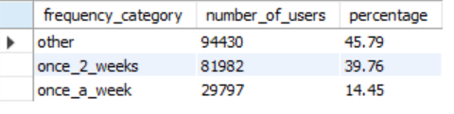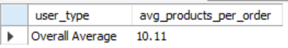
Figure 1 Figure 2
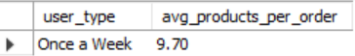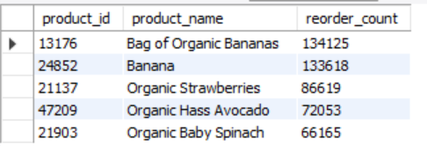
Figure 3 Figure 4
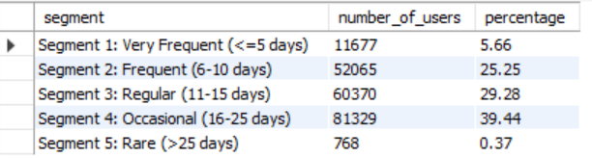
Figure 5
Next, in the analysis, I looked at products which lead to queries 6 to 13. Query 6 addresses the department with the most and least units ordered. Figure 6, 7, 8, and 9. Produce has the most units ordered at 9,888,378 units and Bulk has the least number of units ordered at 35,932 units. I also looked at products ordered in which personal care had the most products ordered at 6,563 products and bulk at 38 products ordered. Query 7 addresses products that have never been ordered in Figure 10. The results were Protein Granola Apple Crisp, Unpeeled Apricot Halves in Heavy Syrup, and Single Barrel Kentucky Straight Bourbon Whiskey. These are products that I would consider removing from the database. Query 8 addresses the aisle with the highest-selling products in Figure 11 which results in fresh vegetables at 29 products. Query 10 addresses the top 10 products most often added first to the cart in Figure 12. The produce department is the most often first picked. Query 11 addresses if the top 10 most-ordered products are likely to be re-ordered in Figure 13. After evaluation, organic items are most likely to be re-ordered. Query 12 addresses organic vs non-organic product sales in Figure 14. The analysis reveals non-organic products have the highest sales.
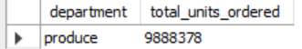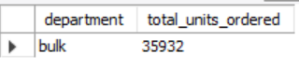
Figure 6 Figure 7
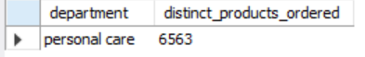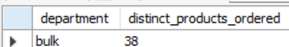
Figure 8 Figure 9
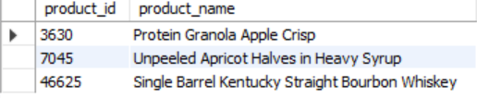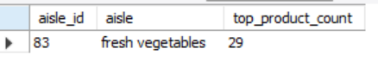
Figure 10 Figure 11
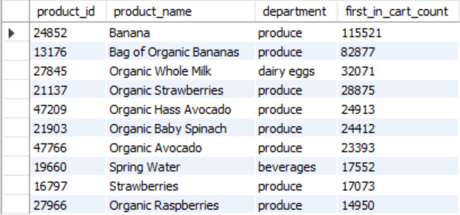
Figure 12
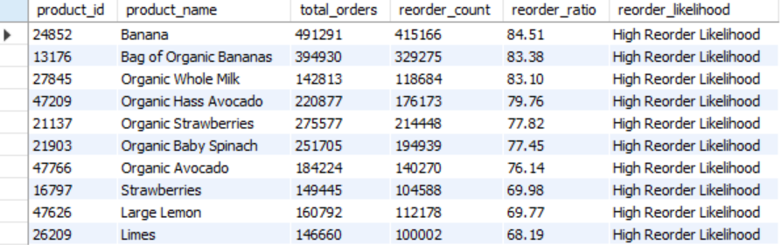
Figure 13
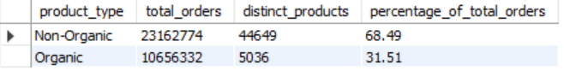
Figure 14
Next, I analyzed the operational efficiency of the orders through queries 14, 15, and 16. Query 14 addresses the weekday with the highest and lowest number of orders in Figure 15, 16, and 17. Saturday has the highest number of orders at 600,905 orders and Wednesday has the lowest at 426,339 orders. Figure 17 addresses the total orders over all the days of the week showing weekends with the highest percentage of orders at over 17% of total orders. Query 15 addresses the percentage of orders placed during the daytime (8am – 5pm) in Figure 18. 76.82% of all orders are placed during this time totaling 3,421,083 orders. Query 16 addresses the top 3 prime time-weekday combinations for re-orders in Figure 19. The analysis reveals the highest prime time to be Sunday at 10 am followed by Saturday at 2-3pm.
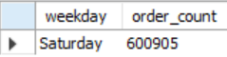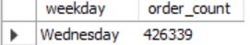
Figure 15 Figure 16
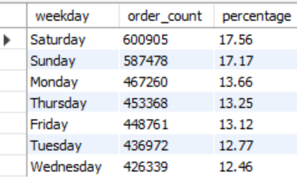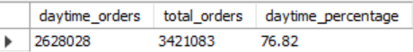
Figure 17 Figure 18
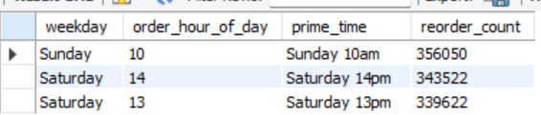
Figure 19
Finally, I completed some basic statistics to show overall metrics that I valued to be important to my analysis. The total product orders are 33,819, 106, users: 206,209, and total order: 3,421,083. Figure 20 just shows the overall metrics that are covered throughout my analysis of the Instacart dataset and Instacart as an overall company.
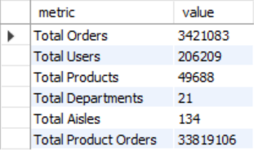
Figure 20
Question 4, 9, and 13 could not be ran. They timed out so they are left out of the query results. They aimed to predict the relationship between re-orders and add-to-cart orders, products ordered once in top-selling aisles, and the top 5 products ordered per department. Ultimately, they did not hurt my analysis by being left out. They would have added valuable input if I wanted to look at the relationship between people who want to shop using Instacart but do not or the products in which are in top selling aisles which only pertains to restocking. I did not uncover either of those problems within my other queries so these almost become obsolete.
The critical findings of my analysis are as such: almost half of users order over a month in between orders, top products have a high reorder rate, organic products are less than 32% of orders, and weekend shopping dominates the number of shoppers for the company. I recommend implementing frequency improvement programs to increase the repeat business and frequency of users and subscription service launch to boost frequency of Instacart used through discounts and auto-order options. Lastly, I recommend that staffing be increased during peak times such as weekends to allow for delivery improvement.

